**Introduction to Generative AI**

**Generative AI:**

*Definition:* A branch of artificial intelligence focused on creating new data or content that mimics real-world data. often in the form of text, images, or even audio.

**The foundation of generative A**I architecture rests on four essential pillars, each critical to transforming raw data into creative outputs.

**1. Data Processing Layer:** This initial stage prepares the raw inputs—text, images, and audio—ensuring they are in a format the AI can understand. It involves cleaning text, encoding audio, and adjusting images, akin to setting the stage for an artist.

**2. Generative Model Layer**: At the heart of the architecture, this layer houses the algorithms like GANs (Generative Adversarial Networks) and VAEs (Variational Autoencoders) that identify patterns and correlations in data to generate new, unseen outputs.

**3. Improvement and Feedback Layer:** Recognizing the imperfections in initial attempts, this layer employs a cycle of feedback and adjustments to refine the models. It's where human judgement and automated assessments converge to enhance the AI's capabilities.

**4. Integration and Deployment Layer:** The final step involves integrating the trained models into real-world applications, from digital art creation to writing aids, demonstrating the vast potential of generative AI to innovate across domains.

**Some popular Approaches of Generative AI include:**

**GANs (Generative Adversarial Networks):** GANs consist of two neural networks, a generator, and a discriminator, which work in opposition to produce realistic outputs. GANs have been used to create realistic images, deep fakes, and more.

**VAEs (Variational Autoencoders):** VAEs are used to generate data by learning the underlying structure and variability within a dataset. They have applications in image generation and text generation.

**Recurrent Neural Networks (RNNs):** RNNs are used for sequence-to-sequence tasks, making them suitable for text generation, language translation, and more.

Generative AI is a broad field with applications across various domains,including art, entertainment, content generation, and even scientific research.

**Importance of Generative AI in Various Applications:**

Generative AI has numerous applications across various domains, including natural language processing, creative content generation, virtual assistants, chatbots, recommendation systems, and more.

Its ability to generate human-like text opens up possibilities for automating content creation, personalising user experiences, and enhancing communication between humans and machines.

**Key characteristics of Generative AI:**

a. Creativity: Generative AI systems are designed to be creative and produce content that is not found in their training data. They can generate new ideas, artworks, or text that is unique and often unpredictable.

b. Variability: These models can produce a wide range of outputs, making them useful in creative tasks such as art, music, and storytelling.

c. Not language-focused: While Generative AI can work with text, it is not limited to language generation and can be used for various creative applications.

### **Use Cases of Generative AI**

**1.Text Generation:**

*Description*: Generative AI models, such as GPT (Generative Pre-trained Transformer) and LSTM (Long Short-Term Memory) networks, are employed for generating human-like text across various domains.

*Examples:* Auto-completion in search engines, content creation for marketing, and storytelling applications.

**2.Image Synthesis:**

*Description:* Generative models like GANs (Generative Adversarial Networks) are utilised to synthesise realistic images from scratch.

*Examples:* Creating artwork, generating photorealistic images for virtual environments, and enhancing resolution in medical imaging.

**3.Data Augmentation:**

*Description:* Generative models are employed to augment datasets by generating synthetic data instances, thereby improving model performance and generalisation.

*Examples:* Augmenting training data for machine learning models in healthcare, finance, and autonomous vehicles.

**4.Creative Design:**

*Description:* Generative AI is utilised in creative industries to assist in design

tasks by generating novel ideas and concepts.

*Examples:* Designing logos, architecture, fashion, and product prototypes.

**5.Anomaly Detection:**

*Description:* Generative AI models can identify anomalies or outliers in datasets by learning the underlying patterns of normal data distribution.

*Examples:* Detecting fraudulent transactions in banking, identifying defects in manufacturing processes, and diagnosing anomalies in medical images.

**6.Personalization and Recommendation:**

*Description:* Generative models are used to personalise user experiences and provide tailored recommendations by understanding user preferences.

*Examples:* Personalised product recommendations in e-commerce, content recommendations in streaming platforms, and adaptive interfaces in applications.

**Advantages of AI:**

**1. Automation:** AI enables automation of repetitive tasks, leading to increased efficiency and productivity in various industries.

**2. Decision Support:** AI systems can analyse vast amounts of data to provide valuable insights and support decision-making processes.

**3. Personalization:** AI algorithms can personalise user experiences by understanding preferences and behaviours, improving customer satisfaction.

**4. Innovation:** AI fosters innovation by enabling the development of novel technologies and solutions, driving progress in diverse fields.

**5. Predictive Capabilities:** AI models can forecast trends, identify patterns, and predict outcomes, aiding in strategic planning and risk management.

**6. Improved Healthcare:** AI applications in healthcare facilitate early disease detection, personalised treatment plans, and medical image analysis, leading to better patient outcomes.

**Challenges of AI:**

**1. Ethical Concerns:** AI raises ethical issues related to bias, privacy violations, job displacement, and autonomous decision-making with potential societal impacts.

**2. Bias and Fairness**: AI algorithms may exhibit biases inherent in training data, leading to unfair outcomes and discrimination against certain groups.

**3. Data Privacy:** AI systems rely on large datasets, raising concerns about data privacy, security breaches, and unauthorised access to sensitive information.

**4. Interpretability and Transparency**: The complexity of AI models makes them difficult to interpret, posing challenges for understanding their decision-making processes and ensuring transparency.

**5. Regulatory Compliance:** The rapid advancement of AI technology requires robust regulatory frameworks to address legal, ethical, and safety considerations, which can be challenging to implement and enforce.

**6. Job Displacement and Economic Disruption:** AI-driven automation may lead to job displacement and economic disruption, requiring proactive measures for workforce reskilling and societal adaptation.

[**Link to learn about**  **Large Language Models (LLMs) & USE CASES**](https://docs.google.com/presentation/d/1cF-00-_psdNJseEraGWCCUKvXON-ce7k5T7mTK5fZSQ/edit#slide=id.g2c121413019_0_18)

**The Transformer Architecture: The Building Block**

What are transformers?

Transformers are a type of neural network that use attention mechanisms to encode and decode text sequences. Unlike recurrent or convolutional neural networks, transformers do not rely on sequential processing, which makes them faster and more flexible. Transformers can capture long-range dependencies and complex patterns in text, which are essential for natural language understanding and generation.

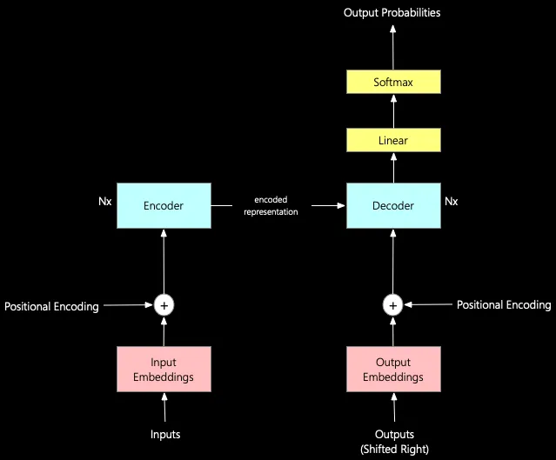

The transformer architecture is the fundamental building block of all Language Models with Transformers (LLMs). The transformer architecture was introduced in the paper “[Attention is all you need](https://arxiv.org/pdf/1706.03762.pdf),” published in December 2017.

The Transformer architecture comprises **seven** crucial components:

**1. Inputs and Input Embeddings:** Convert user-entered tokens into numerical input embeddings, aiding machine learning models in processing text by representing words as numbers.

**2. Positional Encoding:** Assigns numerical values to each word's position in the input sequence, enabling the Transformer model to comprehend the sequential order of words for generating coherent output.

**3. Encoder:** Processes input text by tokenization and applies self-attention layers to generate hidden states representing the text's meaning and context across multiple layers.

**4. Outputs (shifted right):** During training, the decoder predicts the next word based on preceding words, trained on extensive text data to ensure coherence and relevance.

**5. Output Embeddings:** Convert model predictions into numerical "output embeddings," undergo positional encoding, and contribute to training through a loss function that adjusts model parameters for improved accuracy.

**6. Decoder:** Generates output sequence based on encoded input sequence and context learned by the encoder, with multiple layers of decoders utilized in the transformer architecture.

**7. Linear Layer and Softmax:** Maps decoder-produced output embeddings to a higher-dimensional space and employs the softmax function to generate a probability distribution for each output token in the vocabulary, enabling token generation with probabilities.

**Generating Text with Transformers**

**How do transformers generate text?**

Transformers generate text by using a decoder network that takes an input sequence, such as a prompt or a source language sentence, and outputs a target sequence, such as a continuation or a translation. The decoder network uses a masked self-attention layer, which allows it to focus on the relevant parts of the input and the previous outputs, and a cross-attention layer, which allows it to attend to the encoder network outputs. The decoder network then applies a softmax layer to produce a probability distribution over the vocabulary, and selects the most likely token to append to the output sequence.

**Training Process:**

**Input Data Preprocessing:** Raw text data is preprocessed into numerical format (input embeddings) and encoded with positional information.

**Model Training:** The preprocessed data is used to train the Transformer model through iterations, adjusting model parameters to minimise prediction errors.

**Decoding:** During training, decoding involves generating text one token at a time based on the model's learned parameters and the context of previously generated tokens.

**Applications of Text Generation using Transformers:**

* **Content Creation:** Transformers are utilised for generating human-like text in various domains, including writing articles, generating product descriptions, and composing poetry.
* **Chatbots and Conversational Agents**: Transformers power chatbots and conversational agents capable of engaging in natural and contextually relevant conversations.
* **Language Translation:** Transformers facilitate accurate and context-aware translation of text across different languages, enabling seamless communication.
* **Summarization and Captioning:** Transformers can summarise long texts or generate captions for images and videos, condensing information into concise and informative snippets.

**How can you train transformers for multilingual text generation?**

One way to train transformers for multilingual text generation is to use a shared vocabulary and a shared encoder-decoder network for multiple languages. This approach, known as zero-shot or few-shot learning, enables the model to transfer knowledge across languages and generate text in languages that it has not seen during training. For example, you can train a transformer model on English-French and English-German parallel corpora, and then use it to generate text in French-German or German-French.

**How can you fine-tune transformers for specific tasks and domains?**

Another way to use transformers for multilingual text generation is to fine-tune them for specific tasks and domains, such as summarization, question answering, or sentiment analysis. This approach, known as transfer learning, leverages the pre-trained weights and representations of a large-scale transformer model, such as BERT or GPT-3, and adapts them to a smaller and more specialised dataset. For example, you can fine-tune a pre-trained multilingual BERT model on a dataset of customer reviews in different languages, and then use it to generate summaries or responses in the same or different languages

# 

# 

# 

# **The Generative AI Life-cycle**

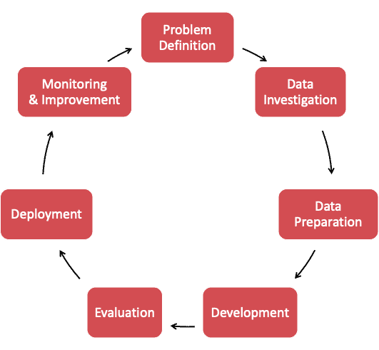

Below is an explanation of each life cycle phase:

**1. Problem Definition:**

Define business objectives, scope, and desired outcomes of the GenAI application to address specific challenges or opportunities.

**2. Data Investigation:**

Source and assess data availability, relevance, and quality to supplement the Large Language Model (LLM) and enable Retrieval-Augmented Generation (RAG).

**3. Data Preparation:**

Clean, format, and structure data for optimal utilisation with GenAI models, including processing and embedding data into a vector store database.

**4. Development:**

Utilise appropriate LLM models, integrate RAG, and design effective prompts for generating desired outputs. Fine-tune LLM if necessary.

**5. Evaluation:**

Rigorously test agent correctness, readability, performance, and reliability against predefined criteria and business needs.

**6. Deployment:**

Set up infrastructure for hosting, scaling, and managing the agent in the intended environment, ensuring seamless integration into existing systems.

**7. Monitoring and Improvement:**

Continuously monitor agent performance, user satisfaction, and operational efficiency. Update and improve the agent based on feedback and evolving business requirements.

[Educational Video to learn about Gen AI](https://youtu.be/G2fqAlgmoPo?si=S_USWoEpuenyqfOg)

[Quiz Questions on Generative AI](https://docs.google.com/document/d/1o-FkG6Uip7Fo7CmNPrk62pXFOf-gjK2t5rz0M1idEy4/edit)

**Relevant courses to learn about generative AI**

Here are resources to help you learn about generative AI:

1. Microsoft Azure AI Fundamentals: Generative AI - This resource provides training on generative AI, explaining how models are trained to generate new content based on natural language input. It's suitable for understanding the basic concepts and applications of generative AI in various domains

<https://learn.microsoft.com/en-us/training/paths/introduction-generative-ai/>

2. Coursera: Introduction to Generative AI - An introductory level microlearning course aimed at explaining what generative AI is, its uses, and how it differs from traditional machine learning methods. This course also covers Google Tools to help develop your own Gen AI apps

<https://www.coursera.org/learn/introduction-to-generative-ai>

3. Google AI: Google Generative AI - This page explains the basics of generative AI, including large language models (LLMs) and their capabilities in generating text, images, videos, or audio.

<https://ai.google/discover/generativeai>

4. MIT News: Explained: Generative AI - A resource from the Massachusetts Institute of Technology that discusses generative AI systems, their underlying algorithms, and the distinctions between generative AI and other types of AI.

<https://news.mit.edu/2023/explained-generative-ai-1109>

5. DataCamp: Generative AI Concepts Course - A non-technical course that introduces key concepts of generative AI and prepares learners for a future where such AIs are pervasive. This course is aimed at those interested in understanding the impact of AI on various domains

<https://www.datacamp.com/courses/generative-ai-concepts>

These links provide a mix of introductory courses, detailed explanations, and technical insights into generative AI, catering to a broad audience from beginners to those seeking deeper understanding.